Lagrange Interpolation
Lagrange interpolation is a well known, classical technique for interpolation [194]. It is also called Waring-Lagrange interpolation, since Waring actually published it 16 years before Lagrange [318, p. 323]. More generically, the term polynomial interpolation normally refers to Lagrange interpolation. In the first-order case, it reduces to linear interpolation.
Given a set of known samples , , the problem is to find the unique order polynomial which interpolates the samples.^{K.1}The solution can be expressed as a linear combination of elementary th order polynomials:
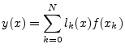
where
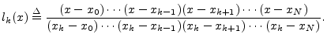
From the numerator of the above definition, we see that is an order polynomial having zeros at all of the samples except the th. The denominator is simply the constant which normalizes its value to at . Thus, we have
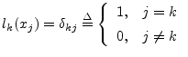
In other words, the polynomial is the th basis polynomial for constructing a polynomial interpolation of order over the sample points . It is an order polynomial having zeros at all of the samples except the th, where it is 1. An example of a set of eight basis functions for randomly selected interpolation points is shown in Fig.K.1.
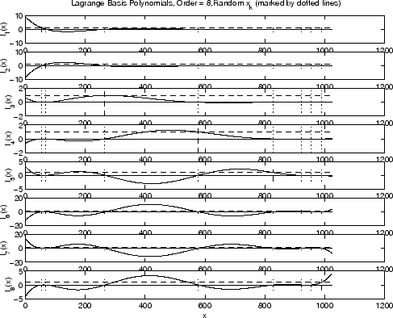
Figure K.1: Example Lagrange basis functions in the eighth-order case for randomly selected interpolation points (marked by dotted lines). The unit-amplitude points are marked by dashed lines.

